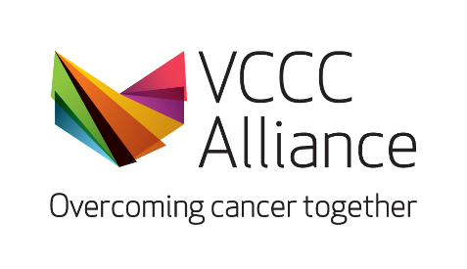

Clinical Trial Protocol Design: Non-Assessed Course

Scholarship Application Form

This form is to be used by VCCC Alliance members or associate members who would like to apply for a $100 fee remission scholarship to support enrolment in the Clinical Trial Protocol Design: Non-Assessed Course.

Kindly note that successful scholarship recipients would have until 31 December 2026 to redeem the scholarship discount code. Following that, recipients have 12 months to complete the course.

Please confirm that:

I have read the statements above.

My organisation is a part of the VCCC Alliance member or associate member organisation.

Title and name of applicant
Health Care, Medical Research Institute or Educational organisation
(e.g. St Vincent’s Hospital)
Department
(e.g. Dept. of Palliative Care)
Current role
(e.g. Head of Haematology, NUM)
An introduction of yourself
What is your current involvement in cancer research, education, or clinical care?
What contribution would this make to your professional development and future career?

Limited to 500 words

Please attach your curriculum vitae to this form and email the scholarship applications to Grace Chan (grace.chan@vcccalliance.org.au)

